**Felix and Rover Project**

**Architectural Specs**

**Front End** – This is the administrator’s dashboard. Here, all user registrations are made available for the administrator. From here, the admin has the option to add, edit or delete user records. The admin also has the ability to manage the details of the pets that are registered (breed, pet, type of pets, products, subscriptions, users, veterinarians).

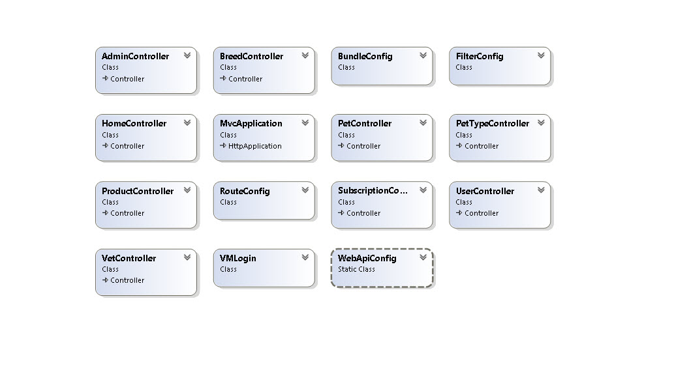

**Vet Front** – This is the veterinarian’s admin dashboard. Here, the vet has the ability to manage records of pets that are registered under their care, including subscriptions, drug products, and post-visit care schedules. Here, the vet can also view his/her income summaries.

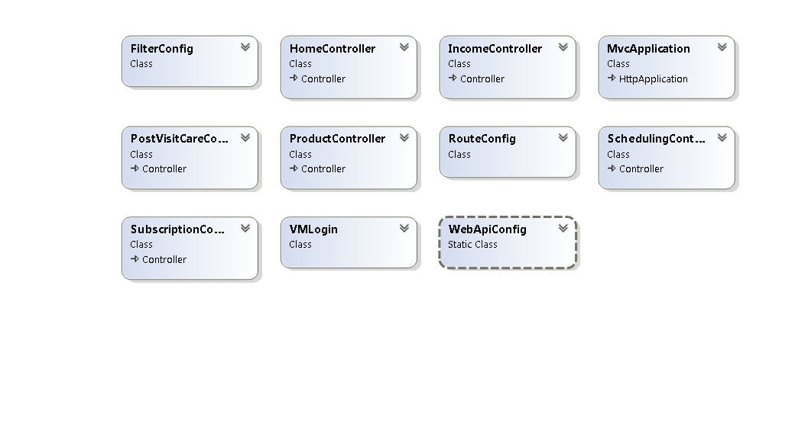

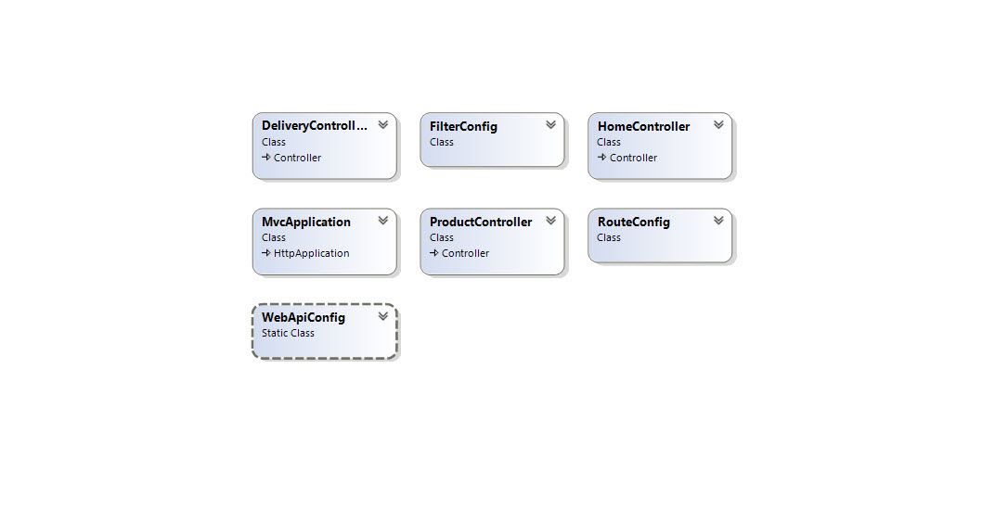**Warehouse** – This page stores all information of all available products for delivery. If a user subscribes to a particular product, it gets stored in the warehouse and regardless of whether there are vets or not, the warehouse still sends out the products. The income will go to the default vet.

**Mobile** – This is the user interface. This is where a user can sign up for a new account or log in to an existing one. Here, a user has the options to register a new pet, add pet details, subscribe to products, and schedule appointments with their vet.